Chip back potential is the level which bulk silicon is maintained by on-chip connection, or it is the level to which the chip back must be connected when specifically stated below. If no potential is given the chip back should be isolated.

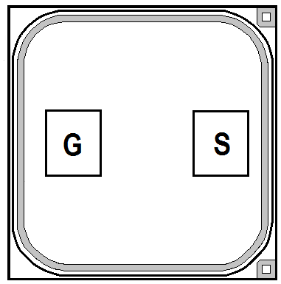
.030”
.030”

CHIP BACK IS DRAIN

Top Material: Al
Backside Material: Ag
Bond Pad Size: .005” X .005”
Backside Potential: Drain
Mask Ref: G19

APPROVED BY: DK DIE SIZE .030” X .030” DATE: 10/5/22
MFG: ZETEX THICKNESS .010” P/N: ZVP3310
DG 10.1.2

Rev B, 7/19/02

